APP BUILDING
Questions
Design an app that can solve numerical methods(secant,rahpson and runge kutta).
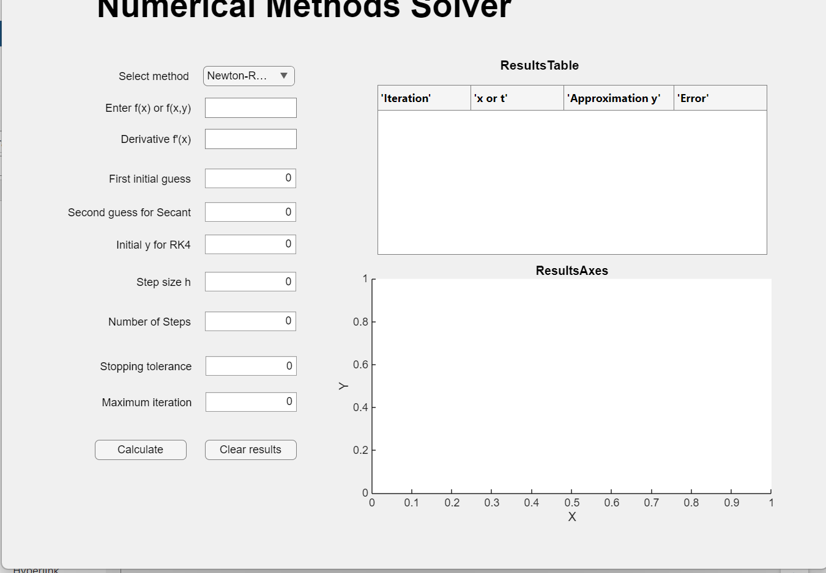
DESIGN VIEW:

CODE VIEW:
classdef NumericalMethodsSolver_Backup < matlab.apps.AppBase

% Properties that correspond to app components
properties (Access = public)
UIFigure matlab.ui.Figure
NumberofStepsEditField matlab.ui.control.NumericEditField
NumberofStepsEditFieldLabel matlab.ui.control.Label
ResultsTableLabel matlab.ui.control.Label
DerivativefxEditField_2 matlab.ui.control.EditField
DerivativefxEditField_2Label matlab.ui.control.Label
DerivativefxEditField matlab.ui.control.EditField
DerivativefxEditFieldLabel matlab.ui.control.Label
EnterfxorfxyEditField matlab.ui.control.EditField
EnterfxorfxyEditFieldLabel matlab.ui.control.Label
UITable matlab.ui.control.Table
ClearresultsButton matlab.ui.control.Button
CalculateButton matlab.ui.control.Button
MaximumiterationEditField matlab.ui.control.NumericEditField
MaximumiterationEditFieldLabel matlab.ui.control.Label
StoppingtoleranceEditField matlab.ui.control.NumericEditField
StoppingtoleranceEditFieldLabel matlab.ui.control.Label
StepsizehEditField matlab.ui.control.NumericEditField
StepsizehEditFieldLabel matlab.ui.control.Label
InitialyforRK4EditField matlab.ui.control.NumericEditField
InitialyforRK4EditFieldLabel matlab.ui.control.Label
SecondguessforSecantEditField matlab.ui.control.NumericEditField
SecondguessforSecantEditFieldLabel matlab.ui.control.Label
FirstinitialguessEditField matlab.ui.control.NumericEditField
FirstinitialguessEditFieldLabel matlab.ui.control.Label
SelectmethodDropDown matlab.ui.control.DropDown
SelectmethodDropDownLabel matlab.ui.control.Label
NumericalMethodsSolverLabel matlab.ui.control.Label
UIAxes matlab.ui.control.UIAxes
end

% Callbacks that handle component events
methods (Access = private)

% Button pushed function: CalculateButton
function CalculateButtonPushed(app, event)

method = strtrim(char(app.SelectmethodDropDown.Value));
equation = strtrim(char(app.EnterfxorfxyEditField.Value));
isNewton = strcmpi(method,"Newton-Raphson");
isSecant = strcmpi(method,"Secant");
isRK4 = strcmpi(method,"Runge-Kutta") || contains(method,"rk4");
if ~isNewton && ~isSecant && ~isRK4
uialert(app.UIFigure,'Please select a valid numerical method.',"Input Error");
return;
end
if isempty(equation)
uialert(app.UIFigure,"Please enter the equation","Input Error");
return;
end
try
if isNewton
x0 = app.FirstinitialguessEditField.Value;
tol = app.StoppingtoleranceEditField.Value;
maxIter = floor(app.MaximumiterationEditField.Value);
derivative = strtrim(char(app.DerivativefxEditField_2.Value));
if isNewton && (~isscalar(x0) || ~isfinite(x0) || ~isscalar(tol)|| tol<=0 || ~isscalar(maxIter) || ~isfinite(maxIter) || maxIter<1 || maxIter ~=floor(maxIter) || isempty(derivative))
uialert(app.UIFigure,"Check the initial guess, derivative, tolerance and maximum iterations.","Input Error");
return;
end

f = str2func(['@(x)' equation]);
df = str2func(['@(x)' derivative]);
data = zeros(maxIter,4);
for k = 1:maxIter
fx = f(x0);
dfx = df(x0);
if ~isfinite(fx) || ~isfinite(dfx) || dfx ==0
error("Invalid function or zero derivative encountered.");
end
x1 = x0- fx/dfx;
err = abs(x1 - x0);
data(k,:) = [k,x1,f(x1),err];
if err<=tol
break;
end
x0 = x1;
end
graphX = data(:,1);
graphY = data(:,2);
xLabelText = "Iteration";
yLabelText = "Root Estimate";
graphTitle = "Newton-Raphson Convergence";
finalMessage = sprintf("Newton-Raphson converged successfully.\nFinal root = %.8f\nIterations = %d",x1,k);
elseif isSecant
x0 = app.FirstinitialguessEditField.Value;
x1 = app.SecondguessforSecantEditField.Value;
tol = app.StoppingtoleranceEditField.Value;
maxIter = app.MaximumiterationEditField.Value;
if ~isscalar(x0) || ~isfinite(x0) || ~isscalar(x1) || ~isfinite(x1) || x0 ==x1 || ~isscalar(tol) || tol<=0 || ~isscalar(maxIter) || ~isfinite(maxIter) || maxIter<1 || maxIter ~=floor(maxIter)
uialert(app.UIFigure,"Check both initial guesses, tolerance and maximum iterations.","Input Error");
return;
end
f = str2func(['@(x)' equation]);
data = zeros(maxIter,4);
for k = 1:maxIter
f0 = f(x0);
f1 = f(x1);
denominator = f1 - f0;
if ~isfinite(f0) || ~isfinite(f1)||denominator == 0
error("Secant method encountered an invalid denominator.");
end
x2 = x1 - f1*(x1 - x0)/denominator;
err = abs(x2 - x1);
data(k,:) = [k,x2,f(x2),err];
if err <= tol
break;
end
x0 = x1;
x1 = x2;
end
data = data(1:k,:);
graphX = data(:,1);
graphY = data(:,2);
graphTitle = "Secant Method Convergence";
xLabelText = "Iteration";
yLabelText = "Root estimate";
finalMessage = sprintf("Secant method completed successfully.\nFinal root = %.8f\nInterations = %d",x2,k);
elseif isRK4
equation = strtrim(char(app.EnterfxorfxyEditField.Value));
y0 = app.InitialyforRK4EditField.Value;
h = app.StepsizehEditField.Value;
n = app.NumberofStepsEditField.Value;
disp(equation);
disp(y0);
disp(h);
disp(n);
disp(['equation empty: ',num2str(isempty(equation))]);
disp(['y0 scalar: ',num2str(isscalar(y0))]);
disp(['y0 finite: ',num2str(isfinite(y0))]);
disp(['h scalar: ',num2str(isscalar(h))]);
disp(['hfinite: ',num2str(isfinite(h))]);
disp(['h<=0: ', num2str(h<=0)]);
disp(['n scalar: ',num2str(isscalar(n))]);
disp(['n finite: ',num2str(isfinite(n))]);
disp(['n<1: ',num2str(n<1)]);
disp(['n not integer: ',num2str(n~= floor(n))]);
disp('REACHED RK4 VALIDATION');
disp(n);
disp(n~= floor(n));
if isempty(equation) || ~isscalar(y0) || ~isfinite(y0) || ~isscalar(h) || ~isfinite(h) || h<=0 || ~isscalar(n) || ~isfinite(n) || n<1 || n~=floor(n)
uialert(app.UIFigure,"Enter a valid equation, initial y, positive step size and positive whole number of steps.","Input Error");
return;
end
f = str2func(['@(x,y)' equation]);
xStart = 0;
x = xStart;
y = y0;
data = zeros(n+1,4);
data(1,:) = [0,x,y,NaN];
for i = 1:n
k1 = f(x,y);
k2 = f(x+h/2,y+(h/2)*k1);
k3 = f(x+h/2,y+(h/2)*k2);
k4 = f(x+h/2,y+(h/2)*k3);
yNew = y+(h/6)*(k1+2*k2+2*k3+k4);
xNew = x+h;
errorValue = abs(yNew -y);
data(i+1,:) = [i,xNew,yNew,errorValue];
x = xNew;
y = yNew;
end
graphX = data(:,2);
graphY = data(:,3);
graphTitle = "Runge-Kutta Fourth Order Method";
xLabelText = "x";
yLabelText = "y";
finalMessage = sprintf("RK4 calculation completed successfully.\nfinal x = %.8f\nFinal y = %.8f\nSteps = %d",x,y,n);
end
app.UITable.Data = data;
app.UITable.ColumnName = {"Iteration","x","Function Value/y","Error"};
cla(app.UIAxes);
plot(app.UIAxes,graphX,graphY,'-O',"LineWidth",1.5,"MarkerSize",5);
xlabel(app.UIAxes,xLabelText);
ylabel(app.UIAxes,yLabelText);
title(app.UIAxes,graphTitle);
grid(app.UIAxes,"on");
uialert(app.UIFigure,finalMessage,"Calculation Results");
catch ME
uialert(app.UIFigure,ME.message,"Calculation Error");
end
end

% Button pushed function: ClearresultsButton
function ClearresultsButtonPushed(app, event)
app.EnterfxorfxyEditField.Value = "";
app.DerivativefxEditField_2.Value = "";
app.FirstinitialguessEditField.Value = 0;
app.SecondguessforSecantEditField.Value = 0;
app.InitialyforRK4EditField.Value = 0;
app.StepsizehEditField.Value = 0.1;
app.NumberofStepsEditField.Value = 10;
app.StoppingtoleranceEditField.Value = 0.000001;
app.MaximumiterationEditField.Value = 100;
app.UITable.Data = [];
cla(app.UIAxes);
title(app.UIAxes,"");
xlabel(app.UIAxes,"");
ylabel(app.UIAxes,"");
end
end

% Component initialization
methods (Access = private)

% Create UIFigure and components
function createComponents(app)

% Create UIFigure and hide until all components are created
app.UIFigure = uifigure('Visible', 'off');
app.UIFigure.Position = [100 100 900 650];
app.UIFigure.Name = 'MATLAB App';

% Create UIAxes
app.UIAxes = uiaxes(app.UIFigure);
title(app.UIAxes, 'ResultsAxes')
xlabel(app.UIAxes, 'X')
ylabel(app.UIAxes, 'Y')
zlabel(app.UIAxes, 'Z')
app.UIAxes.Position = [366 50 482 286];

% Create NumericalMethodsSolverLabel
app.NumericalMethodsSolverLabel = uilabel(app.UIFigure);
app.NumericalMethodsSolverLabel.FontSize = 36;
app.NumericalMethodsSolverLabel.FontWeight = 'bold';
app.NumericalMethodsSolverLabel.Position = [104 594 466 47];
app.NumericalMethodsSolverLabel.Text = 'Numerical Methods Solver';

% Create SelectmethodDropDownLabel
app.SelectmethodDropDownLabel = uilabel(app.UIFigure);
app.SelectmethodDropDownLabel.HorizontalAlignment = 'right';
app.SelectmethodDropDownLabel.Position = [123 528 82 22];
app.SelectmethodDropDownLabel.Text = 'Select method';

% Create SelectmethodDropDown
app.SelectmethodDropDown = uidropdown(app.UIFigure);
app.SelectmethodDropDown.Items = {'Newton-Raphson', 'Secant', 'Runge-Kutta', 'Option 4'};
app.SelectmethodDropDown.Position = [220 528 100 22];
app.SelectmethodDropDown.Value = 'Newton-Raphson';

% Create FirstinitialguessEditFieldLabel
app.FirstinitialguessEditFieldLabel = uilabel(app.UIFigure);
app.FirstinitialguessEditFieldLabel.HorizontalAlignment = 'right';
app.FirstinitialguessEditFieldLabel.Position = [113 416 94 22];
app.FirstinitialguessEditFieldLabel.Text = 'First initial guess';

% Create FirstinitialguessEditField
app.FirstinitialguessEditField = uieditfield(app.UIFigure, 'numeric');
app.FirstinitialguessEditField.Position = [222 416 100 22];

% Create SecondguessforSecantEditFieldLabel
app.SecondguessforSecantEditFieldLabel = uilabel(app.UIFigure);
app.SecondguessforSecantEditFieldLabel.HorizontalAlignment = 'right';
app.SecondguessforSecantEditFieldLabel.Position = [68 379 139 22];
app.SecondguessforSecantEditFieldLabel.Text = 'Second guess for Secant';

% Create SecondguessforSecantEditField
app.SecondguessforSecantEditField = uieditfield(app.UIFigure, 'numeric');
app.SecondguessforSecantEditField.Position = [222 379 100 22];

% Create InitialyforRK4EditFieldLabel
app.InitialyforRK4EditFieldLabel = uilabel(app.UIFigure);
app.InitialyforRK4EditFieldLabel.HorizontalAlignment = 'right';
app.InitialyforRK4EditFieldLabel.Position = [121 344 86 22];
app.InitialyforRK4EditFieldLabel.Text = 'Initial y for RK4';

% Create InitialyforRK4EditField
app.InitialyforRK4EditField = uieditfield(app.UIFigure, 'numeric');
app.InitialyforRK4EditField.Position = [222 344 100 22];

% Create StepsizehEditFieldLabel
app.StepsizehEditFieldLabel = uilabel(app.UIFigure);
app.StepsizehEditFieldLabel.HorizontalAlignment = 'right';
app.StepsizehEditFieldLabel.Position = [143 303 64 22];
app.StepsizehEditFieldLabel.Text = 'Step size h';

% Create StepsizehEditField
app.StepsizehEditField = uieditfield(app.UIFigure, 'numeric');
app.StepsizehEditField.Position = [222 303 100 22];

% Create StoppingtoleranceEditFieldLabel
app.StoppingtoleranceEditFieldLabel = uilabel(app.UIFigure);
app.StoppingtoleranceEditFieldLabel.HorizontalAlignment = 'right';
app.StoppingtoleranceEditFieldLabel.Position = [103 211 105 22];
app.StoppingtoleranceEditFieldLabel.Text = 'Stopping tolerance';

% Create StoppingtoleranceEditField
app.StoppingtoleranceEditField = uieditfield(app.UIFigure, 'numeric');
app.StoppingtoleranceEditField.Position = [223 211 100 22];

% Create MaximumiterationEditFieldLabel
app.MaximumiterationEditFieldLabel = uilabel(app.UIFigure);
app.MaximumiterationEditFieldLabel.HorizontalAlignment = 'right';
app.MaximumiterationEditFieldLabel.Position = [105 172 103 22];
app.MaximumiterationEditFieldLabel.Text = 'Maximum iteration';

% Create MaximumiterationEditField
app.MaximumiterationEditField = uieditfield(app.UIFigure, 'numeric');
app.MaximumiterationEditField.Position = [223 172 100 22];

% Create CalculateButton
app.CalculateButton = uibutton(app.UIFigure, 'push');
app.CalculateButton.ButtonPushedFcn = createCallbackFcn(app, @CalculateButtonPushed, true);
app.CalculateButton.Position = [102 120 100 22];
app.CalculateButton.Text = 'Calculate';

% Create ClearresultsButton
app.ClearresultsButton = uibutton(app.UIFigure, 'push');
app.ClearresultsButton.ButtonPushedFcn = createCallbackFcn(app, @ClearresultsButtonPushed, true);
app.ClearresultsButton.Position = [222 120 100 22];
app.ClearresultsButton.Text = 'Clear results';

% Create UITable
app.UITable = uitable(app.UIFigure);
app.UITable.ColumnName = {'''Iteration'''; '''x or t'''; '''Approximation y'''; '''Error'''};
app.UITable.RowName = {};
app.UITable.Position = [410 344 425 185];

% Create EnterfxorfxyEditFieldLabel
app.EnterfxorfxyEditFieldLabel = uilabel(app.UIFigure);
app.EnterfxorfxyEditFieldLabel.HorizontalAlignment = 'right';
app.EnterfxorfxyEditFieldLabel.Position = [109 493 98 22];
app.EnterfxorfxyEditFieldLabel.Text = 'Enter f(x) or f(x,y)';

% Create EnterfxorfxyEditField
app.EnterfxorfxyEditField = uieditfield(app.UIFigure, 'text');
app.EnterfxorfxyEditField.Position = [222 493 100 22];

% Create DerivativefxEditFieldLabel
app.DerivativefxEditFieldLabel = uilabel(app.UIFigure);
app.DerivativefxEditFieldLabel.HorizontalAlignment = 'right';
app.DerivativefxEditFieldLabel.Position = [126 -48 81 22];
app.DerivativefxEditFieldLabel.Text = 'Derivative f''(x)';

% Create DerivativefxEditField
app.DerivativefxEditField = uieditfield(app.UIFigure, 'text');
app.DerivativefxEditField.Position = [222 -48 100 22];

% Create DerivativefxEditField_2Label
app.DerivativefxEditField_2Label = uilabel(app.UIFigure);
app.DerivativefxEditField_2Label.HorizontalAlignment = 'right';
app.DerivativefxEditField_2Label.Position = [126 459 81 22];
app.DerivativefxEditField_2Label.Text = 'Derivative f''(x)';

% Create DerivativefxEditField_2
app.DerivativefxEditField_2 = uieditfield(app.UIFigure, 'text');
app.DerivativefxEditField_2.Position = [222 459 100 22];

% Create ResultsTableLabel
app.ResultsTableLabel = uilabel(app.UIFigure);
app.ResultsTableLabel.FontSize = 14;
app.ResultsTableLabel.FontWeight = 'bold';
app.ResultsTableLabel.Position = [544 540 91 22];
app.ResultsTableLabel.Text = 'ResultsTable';

% Create NumberofStepsEditFieldLabel
app.NumberofStepsEditFieldLabel = uilabel(app.UIFigure);
app.NumberofStepsEditFieldLabel.HorizontalAlignment = 'right';
app.NumberofStepsEditFieldLabel.Position = [112 260 95 22];
app.NumberofStepsEditFieldLabel.Text = 'Number of Steps';

% Create NumberofStepsEditField
app.NumberofStepsEditField = uieditfield(app.UIFigure, 'numeric');
app.NumberofStepsEditField.Position = [222 260 100 22];

% Show the figure after all components are created
app.UIFigure.Visible = 'on';
end
end

% App creation and deletion
methods (Access = public)

% Construct app
function app = NumericalMethodsSolver_Backup

% Create UIFigure and components
createComponents(app)

% Register the app with App Designer
registerApp(app, app.UIFigure)

if nargout == 0
clear app
end
end

% Code that executes before app deletion
function delete(app)

% Delete UIFigure when app is deleted
delete(app.UIFigure)
end
end
end

SECANT METHOD
Find the root of equation $f\left(x\right)=x^{2}-4x-10$ that lies between 1 and 4?
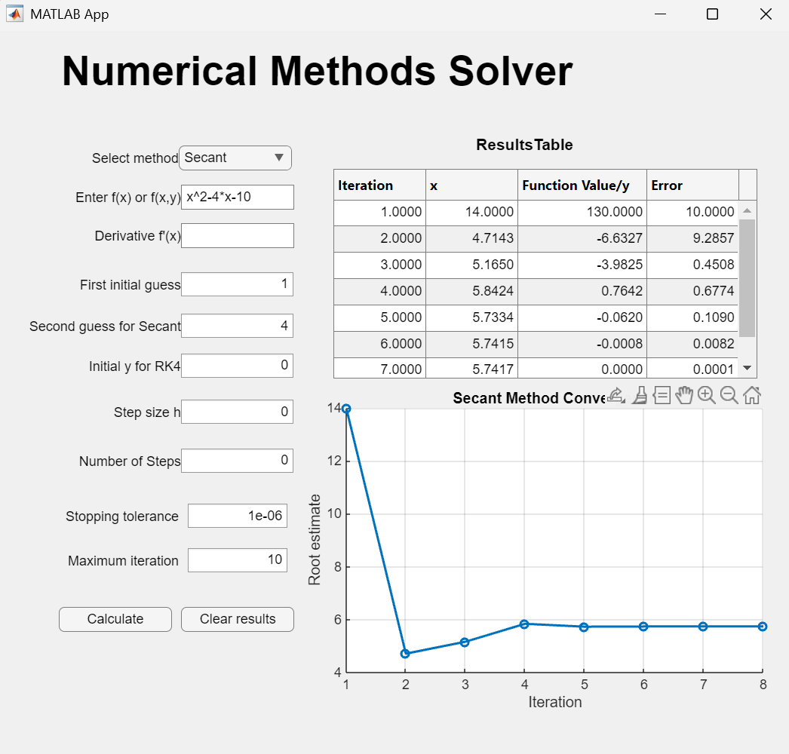
OUTPUT:

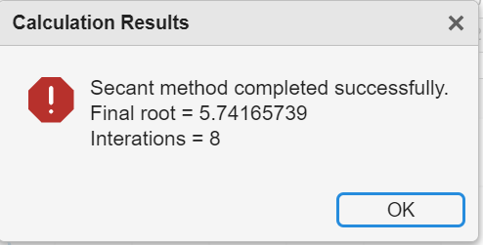

NEWTON RAHPSON METHOD
Use Newton-Raphson method to solve the equation $x^{3}-7x^{2}+5x-4=0$ near $x_{0} =5$ correct to 8 decimal places.
OUTPUT:
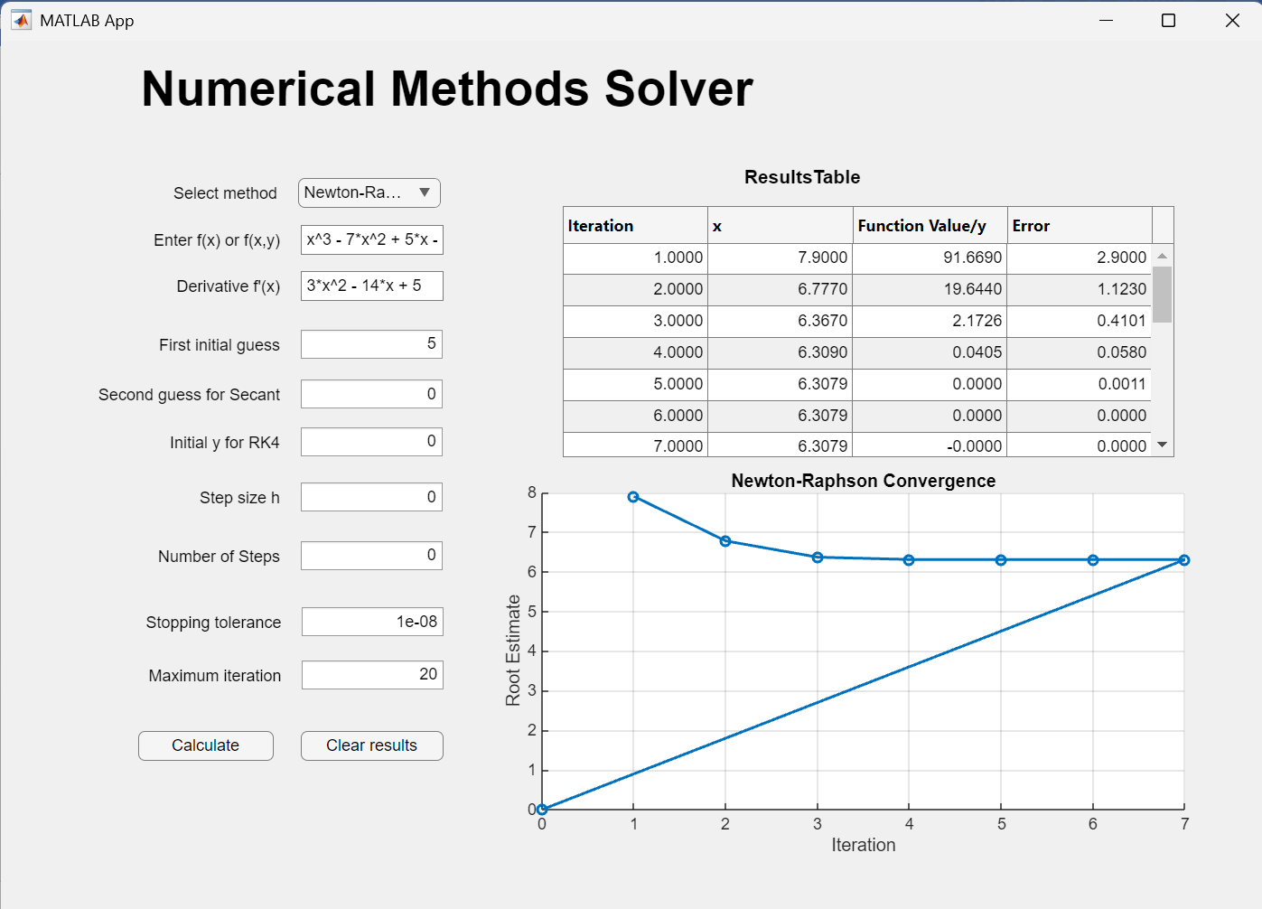

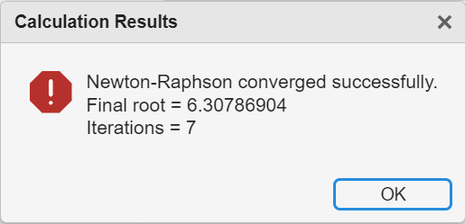
RUNGE KUTTA METHOD
Given the Initial Value Problem (IVP):
$$\frac{d_{y}}{d_{x}}=x+y, y\left(0\right)=1$$
Using the 4th Order Runge-Kutta Method, approximate the value of $y at x = 0.2$ taking a step size $of h = 0.1$
OUTPUT:


